1 run......

training 1 epoch...

10.663024425506592 seconds used......

1 training finished! average train loss: 0.9921456011278289

evaluating...

Confusion matrix, without normalization

[[ 49 35 12]

[ 49 236 70]

[ 59 193 467]]

Normalized confusion matrix

[[0.51041667 0.36458333 0.125 ]

[0.13802817 0.66478873 0.1971831 ]

[0.08205841 0.26842837 0.64951321]]

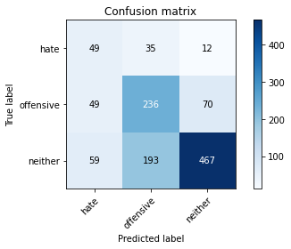

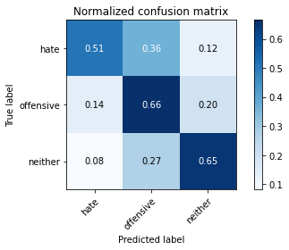

precision recall f1-score support

hate 0.31 0.51 0.39 96

offensive 0.51 0.66 0.58 355

neither 0.85 0.65 0.74 719

accuracy 0.64 1170

macro avg 0.56 0.61 0.57 1170

weighted avg 0.70 0.64 0.66 1170

average eval_loss: 0.7862787357831406, accuracy: 0.6427350427350428

training 2 epoch...

10.872622966766357 seconds used......

2 training finished! average train loss: 0.7353840353233474

evaluating...

Confusion matrix, without normalization

[[ 45 31 20]

[ 34 220 101]

[ 26 99 594]]

Normalized confusion matrix

[[0.46875 0.32291667 0.20833333]

[0.09577465 0.61971831 0.28450704]

[0.03616134 0.13769124 0.82614743]]

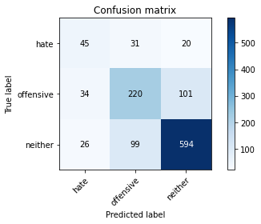

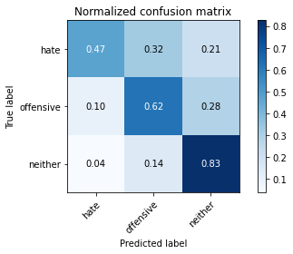

precision recall f1-score support

hate 0.43 0.47 0.45 96

offensive 0.63 0.62 0.62 355

neither 0.83 0.83 0.83 719

accuracy 0.73 1170

macro avg 0.63 0.64 0.63 1170

weighted avg 0.74 0.73 0.74 1170

average eval_loss: 0.6000313228469784, accuracy: 0.7341880341880341

training 3 epoch...

10.903051614761353 seconds used......

3 training finished! average train loss: 0.4427692624075072

evaluating...

Confusion matrix, without normalization

[[ 63 18 15]

[ 47 207 101]

[ 35 64 620]]

Normalized confusion matrix

[[0.65625 0.1875 0.15625 ]

[0.13239437 0.58309859 0.28450704]

[0.04867872 0.08901252 0.86230876]]

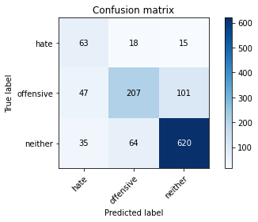

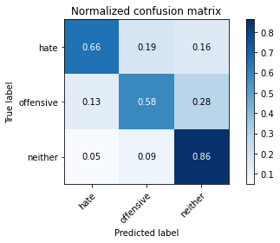

precision recall f1-score support

hate 0.43 0.66 0.52 96

offensive 0.72 0.58 0.64 355

neither 0.84 0.86 0.85 719

accuracy 0.76 1170

macro avg 0.66 0.70 0.67 1170

weighted avg 0.77 0.76 0.76 1170

average eval_loss: 0.5926932754405474, accuracy: 0.7606837606837606

training 4 epoch...

10.881715536117554 seconds used......

4 training finished! average train loss: 0.185230185211237

evaluating...

Confusion matrix, without normalization

[[ 85 5 6]

[ 82 222 51]

[ 84 119 516]]

Normalized confusion matrix

[[0.88541667 0.05208333 0.0625 ]

[0.23098592 0.62535211 0.14366197]

[0.11682893 0.16550765 0.71766342]]

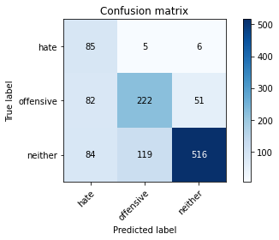

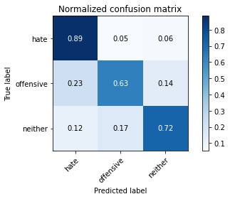

precision recall f1-score support

hate 0.34 0.89 0.49 96

offensive 0.64 0.63 0.63 355

neither 0.90 0.72 0.80 719

accuracy 0.70 1170

macro avg 0.63 0.74 0.64 1170

weighted avg 0.78 0.70 0.72 1170

average eval_loss: 0.9164794163178589, accuracy: 0.7034188034188035

training 5 epoch...

10.804408311843872 seconds used......

5 training finished! average train loss: 0.05015367226276014

evaluating...

Confusion matrix, without normalization

[[ 87 5 4]

[113 192 50]

[ 91 101 527]]

Normalized confusion matrix

[[0.90625 0.05208333 0.04166667]

[0.31830986 0.54084507 0.14084507]

[0.12656467 0.14047288 0.73296245]]

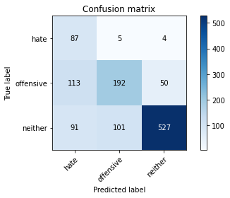

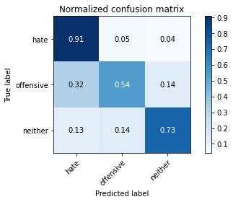

precision recall f1-score support

hate 0.30 0.91 0.45 96

offensive 0.64 0.54 0.59 355

neither 0.91 0.73 0.81 719

accuracy 0.69 1170

macro avg 0.62 0.73 0.62 1170

weighted avg 0.78 0.69 0.71 1170

average eval_loss: 1.1710354195813002, accuracy: 0.6888888888888889

training 6 epoch...

10.852835655212402 seconds used......

6 training finished! average train loss: 0.02841535147828316

evaluating...

Confusion matrix, without normalization

[[ 77 10 9]

[ 66 215 74]

[ 57 94 568]]

Normalized confusion matrix

[[0.80208333 0.10416667 0.09375 ]

[0.18591549 0.6056338 0.2084507 ]

[0.07927677 0.13073713 0.78998609]]

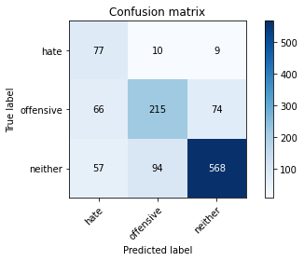

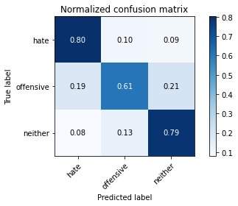

precision recall f1-score support

hate 0.39 0.80 0.52 96

offensive 0.67 0.61 0.64 355

neither 0.87 0.79 0.83 719

accuracy 0.74 1170

macro avg 0.64 0.73 0.66 1170

weighted avg 0.77 0.74 0.75 1170

average eval_loss: 1.0143821763537697, accuracy: 0.7350427350427351

training 7 epoch...

10.752967834472656 seconds used......

7 training finished! average train loss: 0.018812420366365195

evaluating...

Confusion matrix, without normalization

[[ 75 14 7]

[ 68 224 63]

[ 78 95 546]]

Normalized confusion matrix

[[0.78125 0.14583333 0.07291667]

[0.1915493 0.63098592 0.17746479]

[0.10848401 0.13212796 0.75938804]]

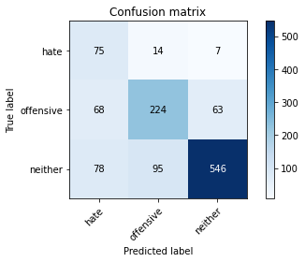

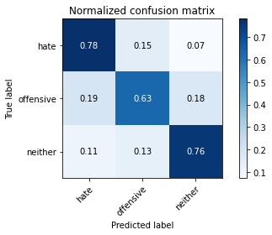

precision recall f1-score support

hate 0.34 0.78 0.47 96

offensive 0.67 0.63 0.65 355

neither 0.89 0.76 0.82 719

accuracy 0.72 1170

macro avg 0.63 0.72 0.65 1170

weighted avg 0.78 0.72 0.74 1170

average eval_loss: 1.1593093076499843, accuracy: 0.7222222222222222

training 8 epoch...

10.896027565002441 seconds used......

8 training finished! average train loss: 0.036361031425518116

evaluating...

Confusion matrix, without normalization

[[ 45 40 11]

[ 21 278 56]

[ 20 161 538]]

Normalized confusion matrix

[[0.46875 0.41666667 0.11458333]

[0.05915493 0.78309859 0.15774648]

[0.02781641 0.22392211 0.74826147]]

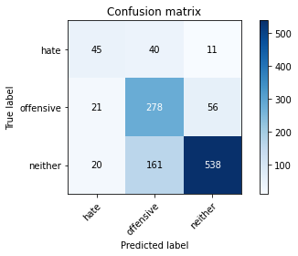

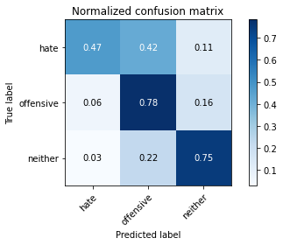

precision recall f1-score support

hate 0.52 0.47 0.49 96

offensive 0.58 0.78 0.67 355

neither 0.89 0.75 0.81 719

accuracy 0.74 1170

macro avg 0.66 0.67 0.66 1170

weighted avg 0.77 0.74 0.74 1170

average eval_loss: 1.0901391056634613, accuracy: 0.735897435897436

training 9 epoch...

10.811067581176758 seconds used......

9 training finished! average train loss: 0.02953052781647005

evaluating...

Confusion matrix, without normalization

[[ 51 26 19]

[ 25 248 82]

[ 19 117 583]]

Normalized confusion matrix

[[0.53125 0.27083333 0.19791667]

[0.07042254 0.69859155 0.23098592]

[0.02642559 0.16272601 0.8108484 ]]

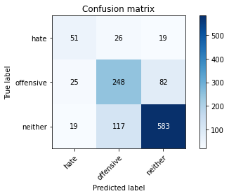

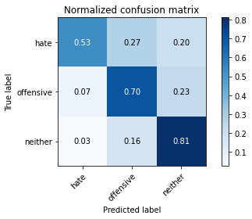

precision recall f1-score support

hate 0.54 0.53 0.53 96

offensive 0.63 0.70 0.66 355

neither 0.85 0.81 0.83 719

accuracy 0.75 1170

macro avg 0.67 0.68 0.68 1170

weighted avg 0.76 0.75 0.76 1170

average eval_loss: 1.0041684754571671, accuracy: 0.7538461538461538

training 10 epoch...

10.886387586593628 seconds used......

10 training finished! average train loss: 0.01360849976377462

evaluating...

Confusion matrix, without normalization

[[ 59 27 10]

[ 40 261 54]

[ 48 141 530]]

Normalized confusion matrix

[[0.61458333 0.28125 0.10416667]

[0.11267606 0.73521127 0.15211268]

[0.06675939 0.1961057 0.73713491]]

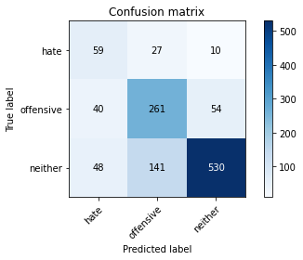

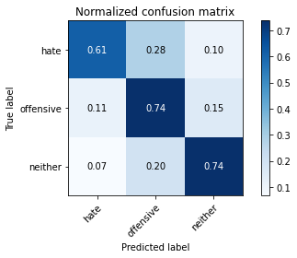

precision recall f1-score support

hate 0.40 0.61 0.49 96

offensive 0.61 0.74 0.67 355

neither 0.89 0.74 0.81 719

accuracy 0.73 1170

macro avg 0.63 0.70 0.65 1170

weighted avg 0.77 0.73 0.74 1170

average eval_loss: 1.1719607587082912, accuracy: 0.7264957264957265

2 run......

training 1 epoch...

10.776300430297852 seconds used......

1 training finished! average train loss: 0.9966430876936231

evaluating...

Confusion matrix, without normalization

[[ 87 2 7]

[216 88 51]

[229 28 462]]

Normalized confusion matrix

[[0.90625 0.02083333 0.07291667]

[0.6084507 0.24788732 0.14366197]

[0.31849791 0.03894298 0.64255911]]

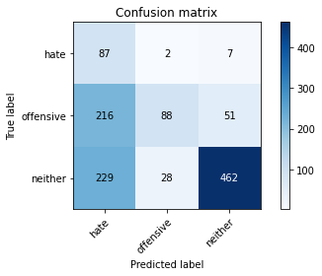

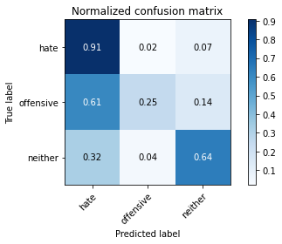

precision recall f1-score support

hate 0.16 0.91 0.28 96

offensive 0.75 0.25 0.37 355

neither 0.89 0.64 0.75 719

accuracy 0.54 1170

macro avg 0.60 0.60 0.46 1170

weighted avg 0.79 0.54 0.59 1170

average eval_loss: 0.9293965242676816, accuracy: 0.5444444444444444

training 2 epoch...

10.741169452667236 seconds used......

2 training finished! average train loss: 0.7225279893193927

evaluating...

Confusion matrix, without normalization

[[ 83 5 8]

[139 117 99]

[ 97 33 589]]

Normalized confusion matrix

[[0.86458333 0.05208333 0.08333333]

[0.3915493 0.32957746 0.27887324]

[0.1349096 0.04589708 0.81919332]]

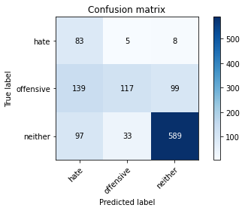

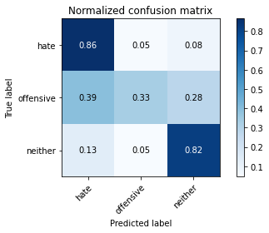

precision recall f1-score support

hate 0.26 0.86 0.40 96

offensive 0.75 0.33 0.46 355

neither 0.85 0.82 0.83 719

accuracy 0.67 1170

macro avg 0.62 0.67 0.56 1170

weighted avg 0.77 0.67 0.68 1170

average eval_loss: 0.7278720216225769, accuracy: 0.6743589743589744

training 3 epoch...

10.714742183685303 seconds used......

3 training finished! average train loss: 0.3975482018930571

evaluating...

Confusion matrix, without normalization

[[ 57 17 22]

[ 33 219 103]

[ 26 61 632]]

Normalized confusion matrix

[[0.59375 0.17708333 0.22916667]

[0.09295775 0.61690141 0.29014085]

[0.03616134 0.08484006 0.87899861]]

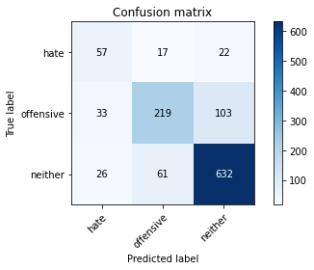

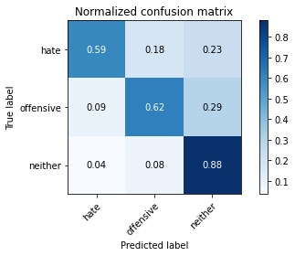

precision recall f1-score support

hate 0.49 0.59 0.54 96

offensive 0.74 0.62 0.67 355

neither 0.83 0.88 0.86 719

accuracy 0.78 1170

macro avg 0.69 0.70 0.69 1170

weighted avg 0.78 0.78 0.77 1170

average eval_loss: 0.5953099025508105, accuracy: 0.7760683760683761

training 4 epoch...

10.759706020355225 seconds used......

4 training finished! average train loss: 0.1520707621904356

evaluating...

Confusion matrix, without normalization

[[ 85 6 5]

[ 98 212 45]

[ 96 85 538]]

Normalized confusion matrix

[[0.88541667 0.0625 0.05208333]

[0.27605634 0.5971831 0.12676056]

[0.13351878 0.11821975 0.74826147]]

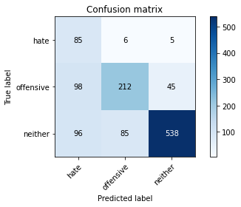

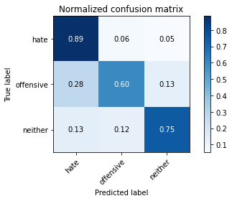

precision recall f1-score support

hate 0.30 0.89 0.45 96

offensive 0.70 0.60 0.64 355

neither 0.91 0.75 0.82 719

accuracy 0.71 1170

macro avg 0.64 0.74 0.64 1170

weighted avg 0.80 0.71 0.74 1170

average eval_loss: 1.047861136369786, accuracy: 0.7136752136752137

training 5 epoch...

10.740022659301758 seconds used......

5 training finished! average train loss: 0.08714516720335398

evaluating...

Confusion matrix, without normalization

[[ 71 12 13]

[ 47 252 56]

[ 50 104 565]]

Normalized confusion matrix

[[0.73958333 0.125 0.13541667]

[0.13239437 0.70985915 0.15774648]

[0.06954103 0.14464534 0.78581363]]

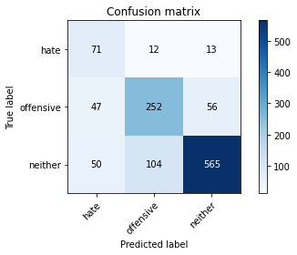

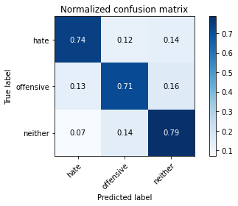

precision recall f1-score support

hate 0.42 0.74 0.54 96

offensive 0.68 0.71 0.70 355

neither 0.89 0.79 0.84 719

accuracy 0.76 1170

macro avg 0.67 0.75 0.69 1170

weighted avg 0.79 0.76 0.77 1170

average eval_loss: 0.9794654237516855, accuracy: 0.7589743589743589

training 6 epoch...

10.711676836013794 seconds used......

6 training finished! average train loss: 0.016942124743114358

evaluating...

Confusion matrix, without normalization

[[ 79 6 11]

[ 63 233 59]

[ 60 93 566]]

Normalized confusion matrix

[[0.82291667 0.0625 0.11458333]

[0.17746479 0.65633803 0.16619718]

[0.08344924 0.12934631 0.78720445]]

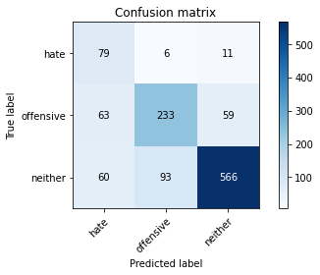

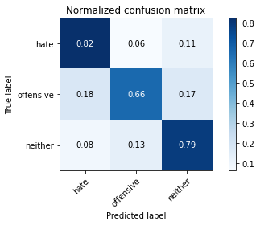

precision recall f1-score support

hate 0.39 0.82 0.53 96

offensive 0.70 0.66 0.68 355

neither 0.89 0.79 0.84 719

accuracy 0.75 1170

macro avg 0.66 0.76 0.68 1170

weighted avg 0.79 0.75 0.76 1170

average eval_loss: 1.1222519723035522, accuracy: 0.7504273504273504

training 7 epoch...

10.841130256652832 seconds used......

7 training finished! average train loss: 0.007900647338829003

evaluating...

Confusion matrix, without normalization

[[ 88 1 7]

[156 137 62]

[105 49 565]]

Normalized confusion matrix

[[0.91666667 0.01041667 0.07291667]

[0.43943662 0.38591549 0.17464789]

[0.14603616 0.06815021 0.78581363]]

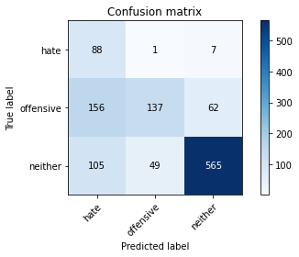

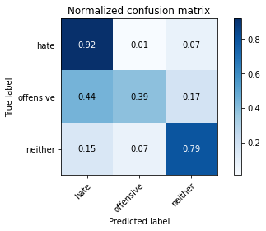

precision recall f1-score support

hate 0.25 0.92 0.40 96

offensive 0.73 0.39 0.51 355

neither 0.89 0.79 0.84 719

accuracy 0.68 1170

macro avg 0.63 0.70 0.58 1170

weighted avg 0.79 0.68 0.70 1170

average eval_loss: 1.7462911075454648, accuracy: 0.6752136752136753

training 8 epoch...

10.758103847503662 seconds used......

8 training finished! average train loss: 0.00943455018568784

evaluating...

Confusion matrix, without normalization

[[ 86 3 7]

[ 95 193 67]

[ 82 61 576]]

Normalized confusion matrix

[[0.89583333 0.03125 0.07291667]

[0.26760563 0.54366197 0.18873239]

[0.11404729 0.08484006 0.80111266]]

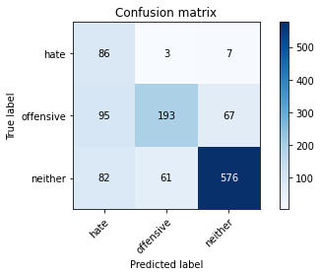

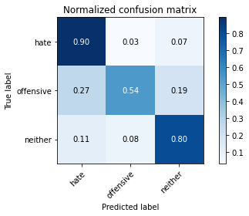

precision recall f1-score support

hate 0.33 0.90 0.48 96

offensive 0.75 0.54 0.63 355

neither 0.89 0.80 0.84 719

accuracy 0.73 1170

macro avg 0.65 0.75 0.65 1170

weighted avg 0.80 0.73 0.75 1170

average eval_loss: 1.4206362545995388, accuracy: 0.7307692307692307

training 9 epoch...

10.839498281478882 seconds used......

9 training finished! average train loss: 0.02636944689896024

evaluating...

Confusion matrix, without normalization

[[ 70 23 3]

[ 38 304 13]

[ 60 313 346]]

Normalized confusion matrix

[[0.72916667 0.23958333 0.03125 ]

[0.10704225 0.85633803 0.03661972]

[0.08344924 0.43532684 0.48122392]]

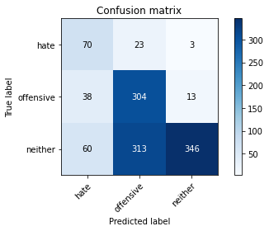

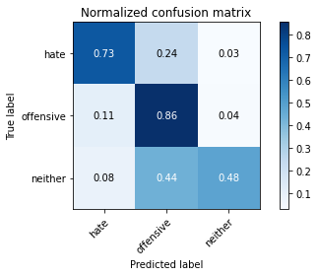

precision recall f1-score support

hate 0.42 0.73 0.53 96

offensive 0.47 0.86 0.61 355

neither 0.96 0.48 0.64 719

accuracy 0.62 1170

macro avg 0.62 0.69 0.59 1170

weighted avg 0.77 0.62 0.62 1170

average eval_loss: 2.0031180109007884, accuracy: 0.6153846153846154

training 10 epoch...

10.738911390304565 seconds used......

10 training finished! average train loss: 0.052848416314061196

evaluating...

Confusion matrix, without normalization

[[ 71 14 11]

[ 68 235 52]

[ 40 108 571]]

Normalized confusion matrix

[[0.73958333 0.14583333 0.11458333]

[0.1915493 0.66197183 0.14647887]

[0.05563282 0.15020862 0.79415855]]

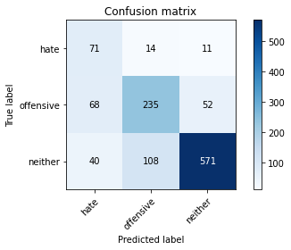

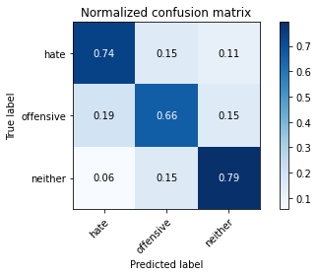

precision recall f1-score support

hate 0.40 0.74 0.52 96

offensive 0.66 0.66 0.66 355

neither 0.90 0.79 0.84 719

accuracy 0.75 1170

macro avg 0.65 0.73 0.67 1170

weighted avg 0.79 0.75 0.76 1170

average eval_loss: 1.0976496066077281, accuracy: 0.7495726495726496

3 run......

training 1 epoch...

10.8353111743927 seconds used......

1 training finished! average train loss: 0.9449817836284637

evaluating...

Confusion matrix, without normalization

[[ 69 22 5]

[ 65 247 43]

[ 86 147 486]]

Normalized confusion matrix

[[0.71875 0.22916667 0.05208333]

[0.18309859 0.69577465 0.12112676]

[0.11961057 0.20445063 0.6759388 ]]

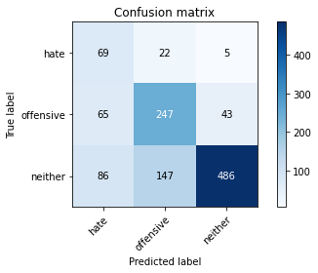

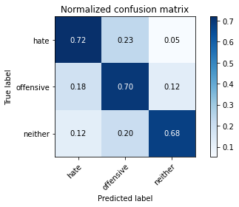

precision recall f1-score support

hate 0.31 0.72 0.44 96

offensive 0.59 0.70 0.64 355

neither 0.91 0.68 0.78 719

accuracy 0.69 1170

macro avg 0.61 0.70 0.62 1170

weighted avg 0.77 0.69 0.71 1170

average eval_loss: 0.7515447180149919, accuracy: 0.6854700854700855

training 2 epoch...

10.748669624328613 seconds used......

2 training finished! average train loss: 0.5670861053679671

evaluating...

Confusion matrix, without normalization

[[ 65 18 13]

[ 61 208 86]

[ 49 82 588]]

Normalized confusion matrix

[[0.67708333 0.1875 0.13541667]

[0.17183099 0.58591549 0.24225352]

[0.06815021 0.11404729 0.8178025 ]]

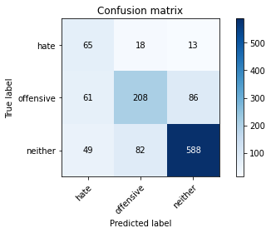

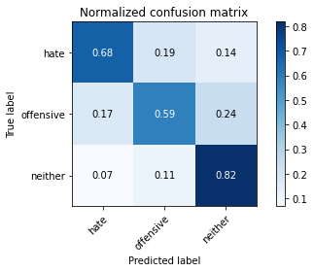

precision recall f1-score support

hate 0.37 0.68 0.48 96

offensive 0.68 0.59 0.63 355

neither 0.86 0.82 0.84 719

accuracy 0.74 1170

macro avg 0.63 0.69 0.65 1170

weighted avg 0.76 0.74 0.74 1170

average eval_loss: 0.5831563924833879, accuracy: 0.735897435897436

training 3 epoch...

10.86339807510376 seconds used......

3 training finished! average train loss: 0.24249205232730933

evaluating...

Confusion matrix, without normalization

[[ 75 13 8]

[ 63 225 67]

[ 73 84 562]]

Normalized confusion matrix

[[0.78125 0.13541667 0.08333333]

[0.17746479 0.63380282 0.18873239]

[0.1015299 0.11682893 0.78164117]]

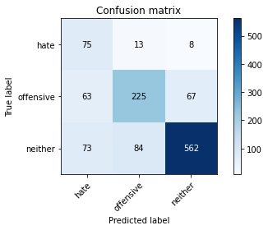

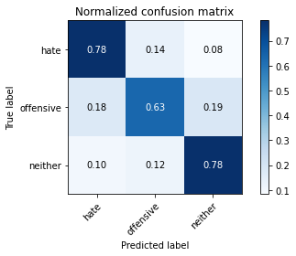

precision recall f1-score support

hate 0.36 0.78 0.49 96

offensive 0.70 0.63 0.66 355

neither 0.88 0.78 0.83 719

accuracy 0.74 1170

macro avg 0.65 0.73 0.66 1170

weighted avg 0.78 0.74 0.75 1170

average eval_loss: 0.7382222318043143, accuracy: 0.7367521367521368

training 4 epoch...

10.784357070922852 seconds used......

4 training finished! average train loss: 0.09420494086641286

evaluating...

Confusion matrix, without normalization

[[ 52 37 7]

[ 26 265 64]

[ 36 116 567]]

Normalized confusion matrix

[[0.54166667 0.38541667 0.07291667]

[0.07323944 0.74647887 0.18028169]

[0.05006954 0.16133519 0.78859527]]

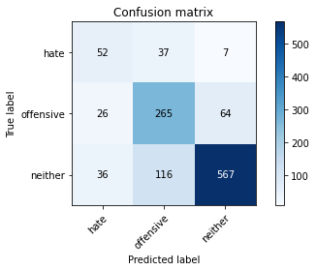

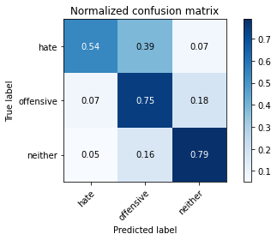

precision recall f1-score support

hate 0.46 0.54 0.50 96

offensive 0.63 0.75 0.69 355

neither 0.89 0.79 0.84 719

accuracy 0.76 1170

macro avg 0.66 0.69 0.67 1170

weighted avg 0.78 0.76 0.76 1170

average eval_loss: 0.7831790970038559, accuracy: 0.7555555555555555

training 5 epoch...

10.82170820236206 seconds used......

5 training finished! average train loss: 0.02588681479184223

evaluating...

Confusion matrix, without normalization

[[ 82 10 4]

[ 73 237 45]

[ 86 126 507]]

Normalized confusion matrix

[[0.85416667 0.10416667 0.04166667]

[0.2056338 0.66760563 0.12676056]

[0.11961057 0.17524339 0.70514604]]

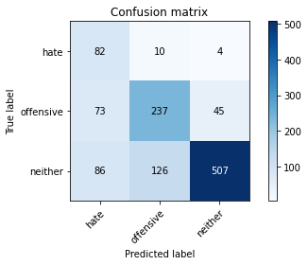

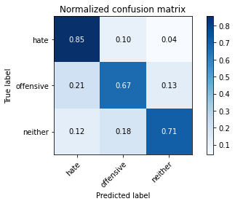

precision recall f1-score support

hate 0.34 0.85 0.49 96

offensive 0.64 0.67 0.65 355

neither 0.91 0.71 0.80 719

accuracy 0.71 1170

macro avg 0.63 0.74 0.64 1170

weighted avg 0.78 0.71 0.73 1170

average eval_loss: 1.1649903240850417, accuracy: 0.705982905982906

training 6 epoch...

10.733792781829834 seconds used......

6 training finished! average train loss: 0.011825511681048997

evaluating...

Confusion matrix, without normalization

[[ 67 18 11]

[ 49 215 91]

[ 40 81 598]]

Normalized confusion matrix

[[0.69791667 0.1875 0.11458333]

[0.13802817 0.6056338 0.25633803]

[0.05563282 0.11265647 0.83171071]]

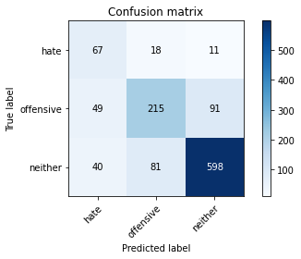

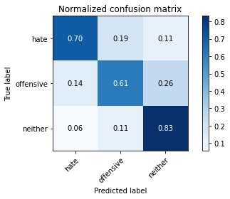

precision recall f1-score support

hate 0.43 0.70 0.53 96

offensive 0.68 0.61 0.64 355

neither 0.85 0.83 0.84 719

accuracy 0.75 1170

macro avg 0.66 0.71 0.67 1170

weighted avg 0.77 0.75 0.76 1170

average eval_loss: 0.9561776417796894, accuracy: 0.7521367521367521

training 7 epoch...

10.834927797317505 seconds used......

7 training finished! average train loss: 0.011471674966742285

evaluating...

Confusion matrix, without normalization

[[ 71 17 8]

[ 56 247 52]

[ 58 128 533]]

Normalized confusion matrix

[[0.73958333 0.17708333 0.08333333]

[0.15774648 0.69577465 0.14647887]

[0.08066759 0.17802503 0.74130737]]

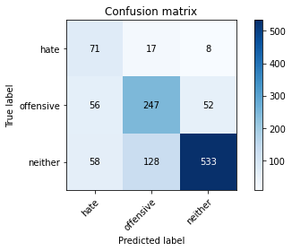

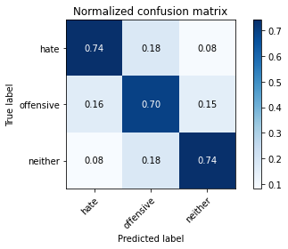

precision recall f1-score support

hate 0.38 0.74 0.51 96

offensive 0.63 0.70 0.66 355

neither 0.90 0.74 0.81 719

accuracy 0.73 1170

macro avg 0.64 0.73 0.66 1170

weighted avg 0.78 0.73 0.74 1170

average eval_loss: 1.1857269206794643, accuracy: 0.7273504273504273

training 8 epoch...

10.702534437179565 seconds used......

8 training finished! average train loss: 0.047057529681686514

evaluating...

Confusion matrix, without normalization

[[ 89 4 3]

[130 169 56]

[125 78 516]]

Normalized confusion matrix

[[0.92708333 0.04166667 0.03125 ]

[0.36619718 0.47605634 0.15774648]

[0.17385257 0.10848401 0.71766342]]

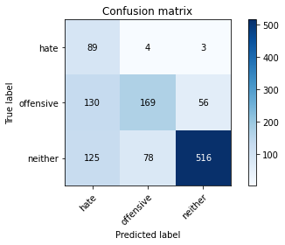

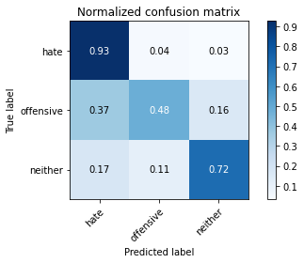

precision recall f1-score support

hate 0.26 0.93 0.40 96

offensive 0.67 0.48 0.56 355

neither 0.90 0.72 0.80 719

accuracy 0.66 1170

macro avg 0.61 0.71 0.59 1170

weighted avg 0.78 0.66 0.69 1170

average eval_loss: 1.2952095694461112, accuracy: 0.6615384615384615

training 9 epoch...

10.760918855667114 seconds used......

9 training finished! average train loss: 0.02254487681368898

evaluating...

Confusion matrix, without normalization

[[ 77 14 5]

[ 72 231 52]

[ 60 132 527]]

Normalized confusion matrix

[[0.80208333 0.14583333 0.05208333]

[0.2028169 0.65070423 0.14647887]

[0.08344924 0.18358832 0.73296245]]

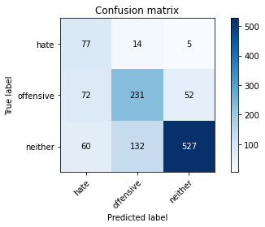

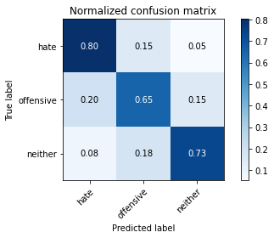

precision recall f1-score support

hate 0.37 0.80 0.50 96

offensive 0.61 0.65 0.63 355

neither 0.90 0.73 0.81 719

accuracy 0.71 1170

macro avg 0.63 0.73 0.65 1170

weighted avg 0.77 0.71 0.73 1170

average eval_loss: 1.235732260144363, accuracy: 0.7136752136752137

training 10 epoch...

10.719678163528442 seconds used......

10 training finished! average train loss: 0.011377172670368705

evaluating...

Confusion matrix, without normalization

[[ 74 16 6]

[ 75 228 52]

[ 70 117 532]]

Normalized confusion matrix

[[0.77083333 0.16666667 0.0625 ]

[0.21126761 0.64225352 0.14647887]

[0.09735744 0.16272601 0.73991655]]

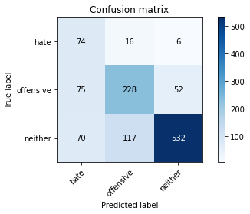

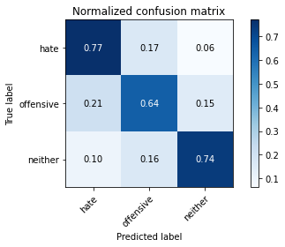

precision recall f1-score support

hate 0.34 0.77 0.47 96

offensive 0.63 0.64 0.64 355

neither 0.90 0.74 0.81 719

accuracy 0.71 1170

macro avg 0.62 0.72 0.64 1170

weighted avg 0.77 0.71 0.73 1170

average eval_loss: 1.288438469424086, accuracy: 0.7128205128205128

4 run......

training 1 epoch...

10.730090379714966 seconds used......

1 training finished! average train loss: 0.9445550463029316

evaluating...

Confusion matrix, without normalization

[[ 69 20 7]

[ 82 223 50]

[101 123 495]]

Normalized confusion matrix

[[0.71875 0.20833333 0.07291667]

[0.23098592 0.62816901 0.14084507]

[0.14047288 0.17107093 0.68845619]]

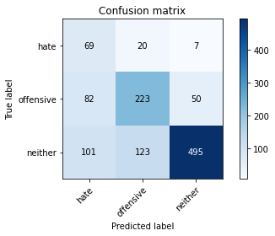

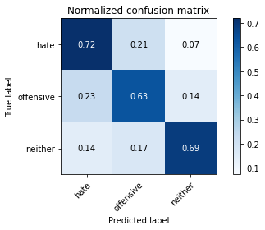

precision recall f1-score support

hate 0.27 0.72 0.40 96

offensive 0.61 0.63 0.62 355

neither 0.90 0.69 0.78 719

accuracy 0.67 1170

macro avg 0.59 0.68 0.60 1170

weighted avg 0.76 0.67 0.70 1170

average eval_loss: 0.7690147247354863, accuracy: 0.6726495726495727

training 2 epoch...

10.782052516937256 seconds used......

2 training finished! average train loss: 0.6147492325731686

evaluating...

Confusion matrix, without normalization

[[ 73 20 3]

[ 72 233 50]

[ 88 101 530]]

Normalized confusion matrix

[[0.76041667 0.20833333 0.03125 ]

[0.2028169 0.65633803 0.14084507]

[0.12239221 0.14047288 0.73713491]]

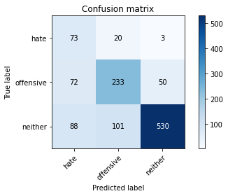

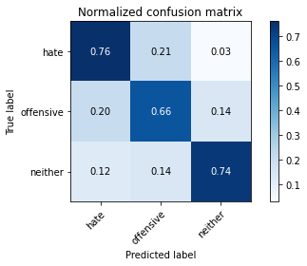

precision recall f1-score support

hate 0.31 0.76 0.44 96

offensive 0.66 0.66 0.66 355

neither 0.91 0.74 0.81 719

accuracy 0.71 1170

macro avg 0.63 0.72 0.64 1170

weighted avg 0.78 0.71 0.74 1170

average eval_loss: 0.696729129653866, accuracy: 0.7145299145299145

training 3 epoch...

10.735190868377686 seconds used......

3 training finished! average train loss: 0.27654704371733324

evaluating...

Confusion matrix, without normalization

[[ 79 13 4]

[ 82 240 33]

[ 76 139 504]]

Normalized confusion matrix

[[0.82291667 0.13541667 0.04166667]

[0.23098592 0.67605634 0.09295775]

[0.10570236 0.19332406 0.70097357]]

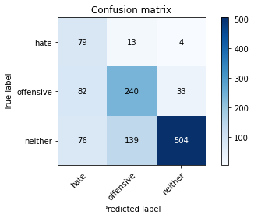

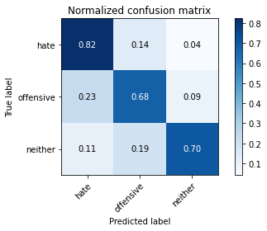

precision recall f1-score support

hate 0.33 0.82 0.47 96

offensive 0.61 0.68 0.64 355

neither 0.93 0.70 0.80 719

accuracy 0.70 1170

macro avg 0.63 0.73 0.64 1170

weighted avg 0.79 0.70 0.73 1170

average eval_loss: 0.8557841030217833, accuracy: 0.7034188034188035

training 4 epoch...

10.843888521194458 seconds used......

4 training finished! average train loss: 0.0818266168269994

evaluating...

Confusion matrix, without normalization

[[ 81 12 3]

[ 85 231 39]

[ 87 119 513]]

Normalized confusion matrix

[[0.84375 0.125 0.03125 ]

[0.23943662 0.65070423 0.10985915]

[0.12100139 0.16550765 0.71349096]]

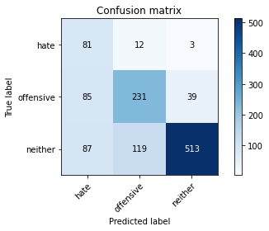

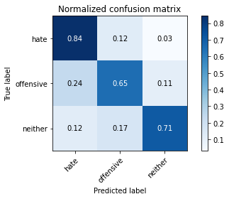

precision recall f1-score support

hate 0.32 0.84 0.46 96

offensive 0.64 0.65 0.64 355

neither 0.92 0.71 0.81 719

accuracy 0.71 1170

macro avg 0.63 0.74 0.64 1170

weighted avg 0.79 0.71 0.73 1170

average eval_loss: 1.078444709464655, accuracy: 0.7051282051282052

training 5 epoch...

10.747910499572754 seconds used......

5 training finished! average train loss: 0.036014501945049106

evaluating...

Confusion matrix, without normalization

[[ 76 19 1]

[ 68 259 28]

[ 82 180 457]]

Normalized confusion matrix

[[0.79166667 0.19791667 0.01041667]

[0.1915493 0.72957746 0.07887324]

[0.11404729 0.25034771 0.63560501]]

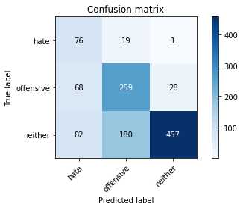

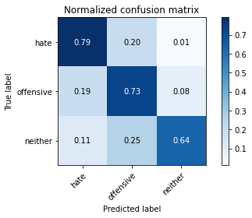

precision recall f1-score support

hate 0.34 0.79 0.47 96

offensive 0.57 0.73 0.64 355

neither 0.94 0.64 0.76 719

accuracy 0.68 1170

macro avg 0.61 0.72 0.62 1170

weighted avg 0.78 0.68 0.70 1170

average eval_loss: 1.3457847737659843, accuracy: 0.676923076923077

training 6 epoch...

10.931804656982422 seconds used......

6 training finished! average train loss: 0.03399317719907101

evaluating...

Confusion matrix, without normalization

[[ 84 8 4]

[ 96 214 45]

[ 96 93 530]]

Normalized confusion matrix

[[0.875 0.08333333 0.04166667]

[0.27042254 0.6028169 0.12676056]

[0.13351878 0.12934631 0.73713491]]

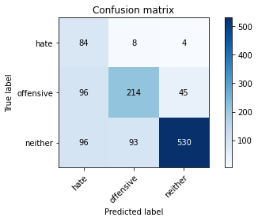

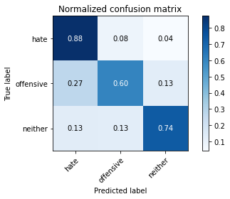

precision recall f1-score support

hate 0.30 0.88 0.45 96

offensive 0.68 0.60 0.64 355

neither 0.92 0.74 0.82 719

accuracy 0.71 1170

macro avg 0.63 0.74 0.64 1170

weighted avg 0.79 0.71 0.73 1170

average eval_loss: 1.3121494052268692, accuracy: 0.7076923076923077

training 7 epoch...

10.723912715911865 seconds used......

7 training finished! average train loss: 0.05753975422287892

evaluating...

Confusion matrix, without normalization

[[ 68 24 4]

[ 42 272 41]

[ 46 164 509]]

Normalized confusion matrix

[[0.70833333 0.25 0.04166667]

[0.11830986 0.76619718 0.11549296]

[0.06397775 0.22809458 0.70792768]]

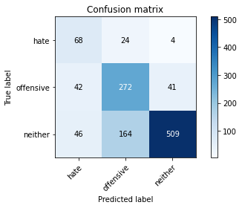

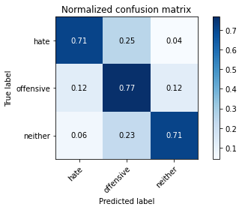

precision recall f1-score support

hate 0.44 0.71 0.54 96

offensive 0.59 0.77 0.67 355

neither 0.92 0.71 0.80 719

accuracy 0.73 1170

macro avg 0.65 0.73 0.67 1170

weighted avg 0.78 0.73 0.74 1170

average eval_loss: 1.1547073827961745, accuracy: 0.7256410256410256

training 8 epoch...

10.862043142318726 seconds used......

8 training finished! average train loss: 0.02591421270751328

evaluating...

Confusion matrix, without normalization

[[ 82 14 0]

[ 80 248 27]

[ 91 190 438]]

Normalized confusion matrix

[[0.85416667 0.14583333 0. ]

[0.22535211 0.69859155 0.07605634]

[0.12656467 0.26425591 0.60917942]]

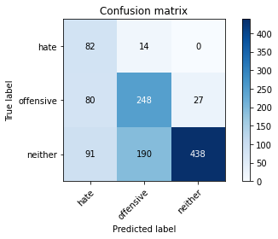

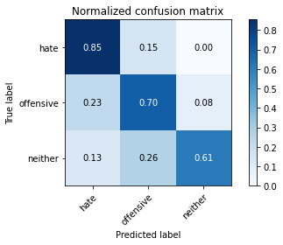

precision recall f1-score support

hate 0.32 0.85 0.47 96

offensive 0.55 0.70 0.61 355

neither 0.94 0.61 0.74 719

accuracy 0.66 1170

macro avg 0.60 0.72 0.61 1170

weighted avg 0.77 0.66 0.68 1170

average eval_loss: 1.7064156370647883, accuracy: 0.6564102564102564

training 9 epoch...

10.747018814086914 seconds used......

9 training finished! average train loss: 0.0154394478044456

evaluating...

Confusion matrix, without normalization

[[ 62 29 5]

[ 40 278 37]

[ 39 193 487]]

Normalized confusion matrix

[[0.64583333 0.30208333 0.05208333]

[0.11267606 0.78309859 0.10422535]

[0.054242 0.26842837 0.67732962]]

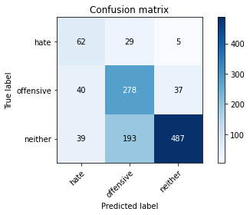

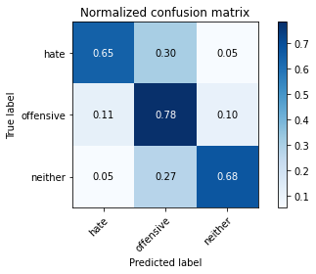

precision recall f1-score support

hate 0.44 0.65 0.52 96

offensive 0.56 0.78 0.65 355

neither 0.92 0.68 0.78 719

accuracy 0.71 1170

macro avg 0.64 0.70 0.65 1170

weighted avg 0.77 0.71 0.72 1170

average eval_loss: 1.2887813600443176, accuracy: 0.7068376068376069

training 10 epoch...

10.84012484550476 seconds used......

10 training finished! average train loss: 0.01735528035819048

evaluating...

Confusion matrix, without normalization

[[ 63 22 11]

[ 47 238 70]

[ 41 85 593]]

Normalized confusion matrix

[[0.65625 0.22916667 0.11458333]

[0.13239437 0.67042254 0.1971831 ]

[0.05702364 0.11821975 0.82475661]]

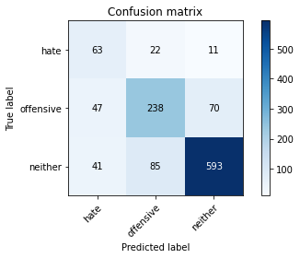

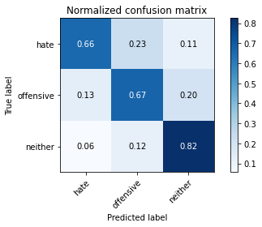

precision recall f1-score support

hate 0.42 0.66 0.51 96

offensive 0.69 0.67 0.68 355

neither 0.88 0.82 0.85 719

accuracy 0.76 1170

macro avg 0.66 0.72 0.68 1170

weighted avg 0.78 0.76 0.77 1170

average eval_loss: 1.0856854385712136, accuracy: 0.764102564102564

5 run......

training 1 epoch...

10.728251695632935 seconds used......

1 training finished! average train loss: 0.9944981560111046

evaluating...

Confusion matrix, without normalization

[[ 45 40 11]

[ 37 274 44]

[ 46 194 479]]

Normalized confusion matrix

[[0.46875 0.41666667 0.11458333]

[0.10422535 0.77183099 0.12394366]

[0.06397775 0.26981919 0.66620306]]

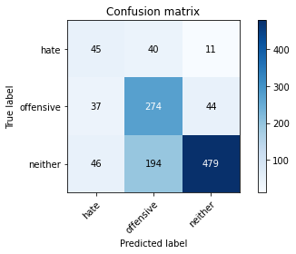

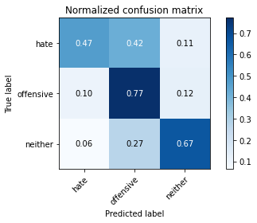

precision recall f1-score support

hate 0.35 0.47 0.40 96

offensive 0.54 0.77 0.63 355

neither 0.90 0.67 0.76 719

accuracy 0.68 1170

macro avg 0.60 0.64 0.60 1170

weighted avg 0.74 0.68 0.70 1170

average eval_loss: 0.7535729721441107, accuracy: 0.6820512820512821

training 2 epoch...

10.803768634796143 seconds used......

2 training finished! average train loss: 0.6582311796290534

evaluating...

Confusion matrix, without normalization

[[ 77 15 4]

[ 95 223 37]

[ 84 136 499]]

Normalized confusion matrix

[[0.80208333 0.15625 0.04166667]

[0.26760563 0.62816901 0.10422535]

[0.11682893 0.1891516 0.69401947]]

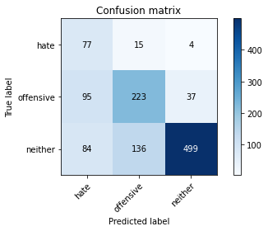

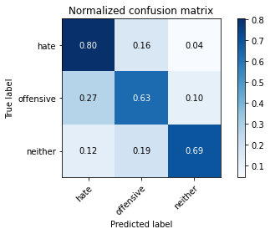

precision recall f1-score support

hate 0.30 0.80 0.44 96

offensive 0.60 0.63 0.61 355

neither 0.92 0.69 0.79 719

accuracy 0.68 1170

macro avg 0.61 0.71 0.61 1170

weighted avg 0.77 0.68 0.71 1170

average eval_loss: 0.76434930855945, accuracy: 0.6829059829059829

training 3 epoch...

10.710417985916138 seconds used......

3 training finished! average train loss: 0.3130423090021525

evaluating...

Confusion matrix, without normalization

[[ 83 10 3]

[ 90 236 29]

[ 84 156 479]]

Normalized confusion matrix

[[0.86458333 0.10416667 0.03125 ]

[0.25352113 0.66478873 0.08169014]

[0.11682893 0.21696801 0.66620306]]

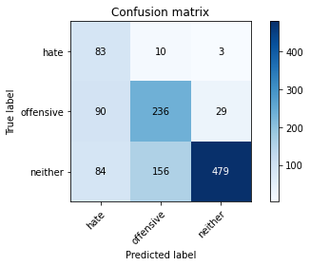

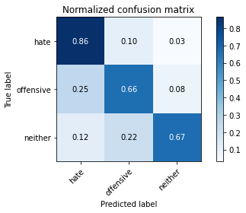

precision recall f1-score support

hate 0.32 0.86 0.47 96

offensive 0.59 0.66 0.62 355

neither 0.94 0.67 0.78 719

accuracy 0.68 1170

macro avg 0.62 0.73 0.62 1170

weighted avg 0.78 0.68 0.71 1170

average eval_loss: 0.9313660728729377, accuracy: 0.6820512820512821

training 4 epoch...

10.830338716506958 seconds used......

4 training finished! average train loss: 0.13225712993049196

evaluating...

Confusion matrix, without normalization

[[ 70 20 6]

[ 51 257 47]

[ 53 147 519]]

Normalized confusion matrix

[[0.72916667 0.20833333 0.0625 ]

[0.14366197 0.72394366 0.13239437]

[0.07371349 0.20445063 0.72183588]]

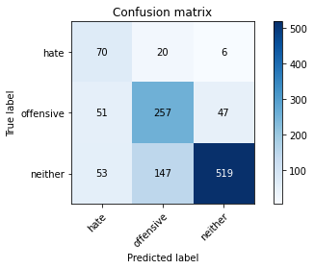

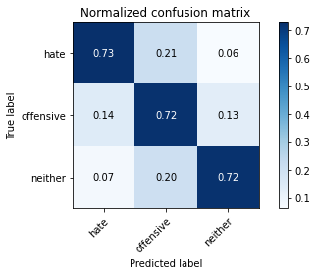

precision recall f1-score support

hate 0.40 0.73 0.52 96

offensive 0.61 0.72 0.66 355

neither 0.91 0.72 0.80 719

accuracy 0.72 1170

macro avg 0.64 0.72 0.66 1170

weighted avg 0.77 0.72 0.74 1170

average eval_loss: 0.9130817015292281, accuracy: 0.7230769230769231

training 5 epoch...

10.737894058227539 seconds used......

5 training finished! average train loss: 0.0419501400486167

evaluating...

Confusion matrix, without normalization

[[ 85 4 7]

[122 167 66]

[101 50 568]]

Normalized confusion matrix

[[0.88541667 0.04166667 0.07291667]

[0.34366197 0.47042254 0.18591549]

[0.14047288 0.06954103 0.78998609]]

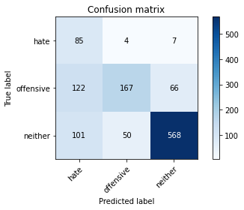

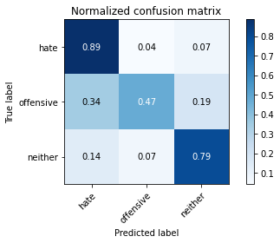

precision recall f1-score support

hate 0.28 0.89 0.42 96

offensive 0.76 0.47 0.58 355

neither 0.89 0.79 0.84 719

accuracy 0.70 1170

macro avg 0.64 0.72 0.61 1170

weighted avg 0.80 0.70 0.72 1170

average eval_loss: 1.3539602892883753, accuracy: 0.7008547008547008

training 6 epoch...

10.836188554763794 seconds used......

6 training finished! average train loss: 0.03226346656031508

evaluating...

Confusion matrix, without normalization

[[ 77 16 3]

[ 86 232 37]

[ 64 159 496]]

Normalized confusion matrix

[[0.80208333 0.16666667 0.03125 ]

[0.24225352 0.65352113 0.10422535]

[0.08901252 0.22114047 0.68984701]]

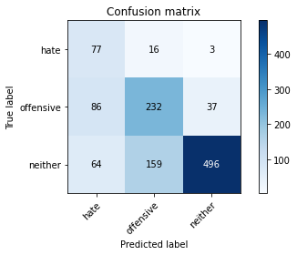

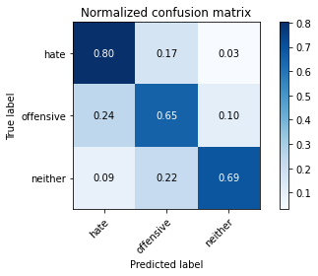

precision recall f1-score support

hate 0.34 0.80 0.48 96

offensive 0.57 0.65 0.61 355

neither 0.93 0.69 0.79 719

accuracy 0.69 1170

macro avg 0.61 0.72 0.63 1170

weighted avg 0.77 0.69 0.71 1170

average eval_loss: 1.313565632801945, accuracy: 0.688034188034188

training 7 epoch...

10.755489349365234 seconds used......

7 training finished! average train loss: 0.014608447812081846

evaluating...

Confusion matrix, without normalization

[[ 85 7 4]

[ 85 231 39]

[ 81 142 496]]

Normalized confusion matrix

[[0.88541667 0.07291667 0.04166667]

[0.23943662 0.65070423 0.10985915]

[0.11265647 0.19749652 0.68984701]]

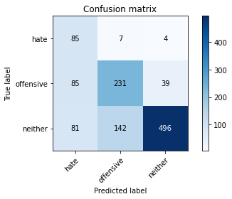

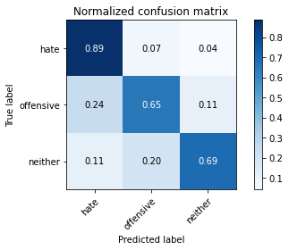

precision recall f1-score support

hate 0.34 0.89 0.49 96

offensive 0.61 0.65 0.63 355

neither 0.92 0.69 0.79 719

accuracy 0.69 1170

macro avg 0.62 0.74 0.64 1170

weighted avg 0.78 0.69 0.72 1170

average eval_loss: 1.4782693239591889, accuracy: 0.694017094017094

training 8 epoch...

10.78239130973816 seconds used......

8 training finished! average train loss: 0.028926009210408665

evaluating...

Confusion matrix, without normalization

[[ 68 20 8]

[ 55 256 44]

[ 57 140 522]]

Normalized confusion matrix

[[0.70833333 0.20833333 0.08333333]

[0.15492958 0.72112676 0.12394366]

[0.07927677 0.19471488 0.72600834]]

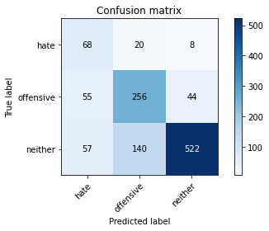

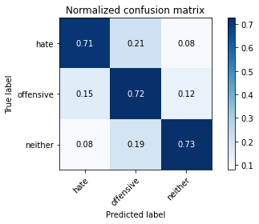

precision recall f1-score support

hate 0.38 0.71 0.49 96

offensive 0.62 0.72 0.66 355

neither 0.91 0.73 0.81 719

accuracy 0.72 1170

macro avg 0.63 0.72 0.65 1170

weighted avg 0.78 0.72 0.74 1170

average eval_loss: 1.1853905009516215, accuracy: 0.7230769230769231

training 9 epoch...

10.729714393615723 seconds used......

9 training finished! average train loss: 0.012860327260568738

evaluating...

Confusion matrix, without normalization

[[ 63 25 8]

[ 38 273 44]

[ 46 166 507]]

Normalized confusion matrix

[[0.65625 0.26041667 0.08333333]

[0.10704225 0.76901408 0.12394366]

[0.06397775 0.23087622 0.70514604]]

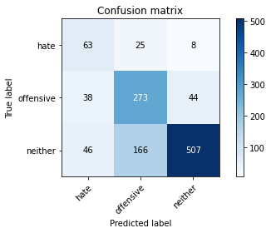

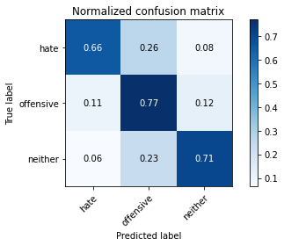

precision recall f1-score support

hate 0.43 0.66 0.52 96

offensive 0.59 0.77 0.67 355

neither 0.91 0.71 0.79 719

accuracy 0.72 1170

macro avg 0.64 0.71 0.66 1170

weighted avg 0.77 0.72 0.73 1170

average eval_loss: 1.2529262824583862, accuracy: 0.7205128205128205

training 10 epoch...

10.748208999633789 seconds used......

10 training finished! average train loss: 0.009965442445328725

evaluating...

Confusion matrix, without normalization

[[ 88 1 7]

[158 131 66]

[113 54 552]]

Normalized confusion matrix

[[0.91666667 0.01041667 0.07291667]

[0.44507042 0.36901408 0.18591549]

[0.15716273 0.07510431 0.76773296]]

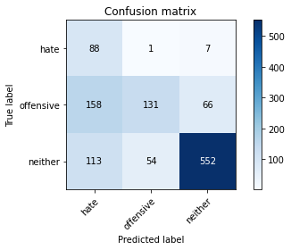

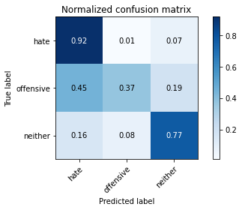

precision recall f1-score support

hate 0.25 0.92 0.39 96

offensive 0.70 0.37 0.48 355

neither 0.88 0.77 0.82 719

accuracy 0.66 1170

macro avg 0.61 0.68 0.56 1170

weighted avg 0.78 0.66 0.68 1170

average eval_loss: 1.8028292236691814, accuracy: 0.658974358974359